**Turbofan engine Remaining Useful Life(RUL) prediction using machine learning**

**A PROJECT REPORT**

***Submitted by***

**Giri S (422520106013)**

**Kanimozhi N (422520106022)**

**Shiyam Ganesh N (422520106701)**

***in partial fulfillment for the award of the degree***

***of***

**BACHELOR OF ENGINEERING**

***In***

***ELECTRONICS AND COMMUNICATION ENGINEERING***



**UNIVERSITY COLLEGE OF ENGINEERING, VILLUPURAM,**

**VILLUPURAM - 605103**

**ANNA UNIVERSITY : CHENNAI - 600 025**

**MAY 2024**

**BONAFIDE CERTIFICATE**

Certified that this project report **" Turbofan engine Remaining Useful Life(RUL) prediction using machine learning"** is the work of **" Giri S (422520106013), Kanimozhi N (422520106022), Shiyam Ganesh N (422520106701)** who carried out the project work under my supervision.

|  |  |  |
| --- | --- | --- |
| SIGNATURE  **Dr. M. PHEMINA SELVI,**  **Assistant Professor (Sl.Gr),**  **HEAD OF THE DEPARTMENT**  Department of Electronics and Communication Engineering  University College of Engineering, Villupuram,  Villupuram- 605103 |  | SIGNATURE  **Mr. E. VENKATRAMAN,**  **SUPERVISOR,**  **Teaching Fellow,**  Department of Electronics and Communication Engineering  University College of Engineering, Villupuram,  Villupuram- 605103 |

Submitted for “EC8611 – Project Work” in B.E of Electronics and Communication Engineering – Apr/May 2024 Examination held on …………….

**Internal Examiner External Examiner**

**ACKNOWLEDGEMENT**

We would like to express our sincere thanks to our valuable and respected **Dean Dr.R.SENTHIL,** University College of Engineering Villupuram for providing good environment and facilities to do this work.

We sincerely thank to **Dr. M.PHEMINA SELVI,** **Head of the Department**, Department of Electronics and communication Engineering, who has greatly helped in the success of the project by providing continuous encouragement.

We deeply thank our project guide **Mr.E.VENKATRAMAN,** Department of Electronics and Communication Engineering, for his guidance, support, motivation throughout our progress of the project.

We thank our project coordinators **Dr. M.PHEMINA SELVI, Mr.R.RAMANATHAN, Mrs.C.MALARVIZHI,** Department of Electronics and Communication Engineering for their valuable support during our project work.

We also thank all the other teaching and non-teaching staff members of the Department of Electronics and Communication Engineering, for their co-operation during our project work.

We express our thanks to our family members and friends for being our moral support throughout our project.

Above all, we thank our almighty God for their gracious blessings for the successful completion of our project.

**Abstract**

Remaining Useful Life prediction of commercial jet engines can be achieved using LSTMDNN, where LSTM (Long- Short Term Memory) is a type of RNNs (Recurrent Neural Network) that can detain long-term dependencies in sequential data. LSTMs are capable to process and analyse sequential data, such as time series, text, and speech for Natural Language Processing (NLP), Speech Recognition, and Time Series Forecasting. So, LSTM techniques can be applied in the Indian commercial jet named Airbus A320 to predict the remaining useful life from its lifetime of 60,000 flight hours with a speed of 830 km/h. In traditional methods for prediction of remaining useful life of commercial jets uses several conventional approaches such as Markov chains, Fault Tree Analysis, and Analytic Hierarchy Process. However, these methods commonly suffer from high False Positive Rates (FPR) and False Negative Rates (FNR), which can be critical and pose a risk to the aircraft. The LSTM-DNN methodology emphasizes simplicity, reduces model complexity and minimize false predictions. To validate the proposed method experimentally, we utilize the C-MAPSS aero engine dataset, which comprises data gathered from 21 sensors, including temperature, pressure, and speed sensors, alongside 18 sensors specifically employed for calculating the Remaining Useful Life (RUL). The Temperature sensors such as IAT, EGT, ECT, Oil Temperature, and Turbocharger Temperature Sensors are integrated, each with specific ranges ensuring accurate data acquisition MAP sensors measure pressures from about 15 kPa to 250 kPa, while Boost Pressure sensors typically range from 100 kPa to 300 kPa or higher. Speed sensors, such as Turbocharger Speed, Wheel Speed, and Transmission Speed Sensors, monitor rotational speeds crucial for engine performance. Such speed sensor values might range from a few 1000 RPM to 10000 RPM. The Quality of the trained LSTM model is assessed by calculating the false positives and false negatives. Evaluation metrics such as precision, recall, F1 score, and accuracy of Remaining Useful Life (RUL) prediction to assess the model quantitatively. This technique can be applied to similar commercial jets, including the Airbus A380, Boeing 747, Airbus A300, Boeing 777, Airbus A321, Antonov, and Beechcraft 1300.

**TABLE OF CONTENTS**

|  |  |  |
| --- | --- | --- |
| **CHAPTER NO.** | **TITLE** | **PAGE NO.** |
|  | **ABSTRACT** | iv |
|  |  |  |
|  | **LIST OF TABLES** | vii |
|  | **LIST OF FIGURES** | viii |
|  | **LIST OF SYMBOLS(ACRONYMS)** | ix |
| 1 | **INTRODUCTION** | 1 |
|  | 1.1 Overview | 1 |
|  | 1.2 Importance  1.3 Existing Methods | 2 |
|  | 1.4 Limitations  1.5 Literature Survey | 2 |
| 2 | **MACHINE LEARNING**  2.1 Deep Learning  2.2 Neural Networks  2.2.1 Types of Neural Networks | 10  12 |
| 3 | **SYSTEM ANALYSIS** |  |
|  | 3.1 Existing Approach | 18 |
|  | 3.2 Limitations of Existing System | 19 |
|  | 3.3 Proposed System | 20 |
|  | 3.4 Steps in Proposed Approach |  |
|  | 3.5 Advantages of Proposed System |  |
|  | 3.6 System Architecture Diagram |  |
|  | 3.7 Data Flow Diagram | 21 |
|  | 3.8 Module Diagram | 22 |
|  | 3.8.1 Dataset Collection | 23 |
|  | 3.8.2 Data Description | 23 |
|  | 3.8.3 Data Preprocessing | 24 |
|  | 3.8.4 Data Exploration | 24 |
|  | 3.8.5 Data Visualization | 25 |
|  | 3.9 Feature Engineering | 30 |
|  | 3.10 Model Building | 32 |
|  | 3.10.1 Existing Approach | 32 |
|  | 3.10.2 Proposed Approach | 38 |
| 4 | **Results and Discussions** | 40 |
| **5** | **Conclusion and Future Works** | 42 |
|  | **References** | 43 |
|  | **Appendices** |  |

**LIST OF TABLES**

|  |  |  |
| --- | --- | --- |
| **S.NO.** | **TITLE** | **PAGE NO** |
| 1 | Data description of turbofan engine sensors | 24 |
| 2 | Sensor trends summary | 29 |

**LIST OF FIGURES**

| **S.NO.** | **Title** | **Page no** |
| --- | --- | --- |
|  |  |  |
| 3.1 | Architecture Diagram | 21 |
| 3.2 | DFD level 0 | 22 |
| 3.3 | DFD level 1 |  |
| 3.4 | Module Diagram | 23 |
| 3.5 | Time vs Cycle plot | 25 |
| 3.6-4.25 | Sensor 1 - 21 | 28 |
| 3.26 | Selected Sensors | 29 |
| 3.27 | Lag Feature | 31 |
| 3.28 | Poly Feature | 32 |
| 3.29 | Architecture of Random Forest | 33 |
| 3.30 | Architecture of Support Vector Regression | 34 |
| 3.31 | Architecture of Linear Regression | 35 |
| 4.1 | Value of LSTM | 41 |

**LIST OF ACRONYMS**

|  |  |
| --- | --- |
| **NASA** | **National Aeronautics and Space Administration** |
| **MARS** | **Multivariate Adaptive Regression Technique** |
| **LSTM** | **Long Short-Term Memory** |
| **CNN** | **Convolutional Neural Network** |
| **DFD** | **Data Flow Diagram** |
| **ML** | **Machine Learning** |
| **RUL** | **Remaining Useful Life** |
| **Psia** | **Pounds Per Square Inch** |
| **Rpm** | **Rotations Per Minute** |
| **C-MAPSS** | **Commercial Modular Aero-System Propulsion Simulation** |

**CHAPTER 1**

**INTRODUCTION**

**1.1 Overview**

The rapid advancement of deep learning techniques has played a significant role in the evolution of engine health management technology. Effective maintenance of flight-critical components including gas Commercial Jet engines plays a significant role in the aircraft industry. Predicting the remaining useful life of the Commercial Jet Engine is an important research area to avoid downtime and failures. Predictive Maintenance is the process of predicting malfunctions using data from equipment monitoring and process performance measurements. The conventional approach to monitoring a Commercial Jet engine's performance is unreliable and more prone to failure. Therefore, this project focuses on designing intelligent decision support for monitoring the Commercial Jet engine performance using a deep learning LSTM algorithm.

During their lifetime, aircraft components are susceptible to degradation, which directly affects their reliability and performance. This deep learning project will be directed to provide a framework for predicting the aircraft’s remaining useful life (RUL) based on the entire life cycle data in order to provide the necessary maintenance behavior.

**1.2 Importance**

Predicting Remaining Useful Life (RUL) is a critical problem in the maintenance and operation of complicated equipment such as the Commercial Jet engine. Based on available information about a system's current status and prior performance, RUL prediction estimates the remaining time until it fails.

**Cost savings:** By predicting RUL, operators can more effectively schedule maintenance activities, avoiding the need for costly unplanned repairs and downtime. It can also help to extend the engine's useful life, avoiding the need for costly replacements.

**Safety:** Accurate RUL prediction can help avert catastrophic failures, which could jeopardize the aircraft's and its occupants' safety.

**Efficiency:** Operators can optimize engine performance and reduce fuel usage by forecasting RUL, resulting in cost savings and lower emissions.

Reliability: RUL prediction can help increase engine reliability by recognizing possible faults before they cause breakdowns.

**1.3 Existing methods**

The Existing method of monitoring the performance of a Commercial Jet engine is unreliable and more prone to failure.

**1.4 Limitations**

They may not capture the underlying physics and mechanics that cause engine degradation. They require a huge amount of high-quality training data to perform accurately.

They may not generalize well to new or unknown operating circumstances or rare and complex failure modes.

**1.5 Literature Survey**

[1] The paper titled **"Aircraft Engine Performance Monitoring and Diagnostics Based on Deep Convolutional Neural Networks"** was published in **2021**. The paper proposes a method to monitor and diagnose the performance of aircraft engines using deep convolutional neural networks (CNNs). The proposed method utilizes sensor data collected from aircraft engines to train a CNN model. The model is designed to learn the complex relationships between the sensor data and the performance of the engine. The trained model is then used to detect engine faults and predict engine performance. The paper includes experimental results that demonstrate the effectiveness of the proposed method in detecting engine faults and predicting engine performance. The results show that the proposed method outperforms traditional methods for engine performance monitoring and diagnostics in terms of accuracy. One advantage of the proposed method is that it can handle large amounts of data and learn complex relationships between the sensor data and engine performance. Additionally, the proposed method can provide early detection of engine faults, which can lead to improved maintenance and reliability of aircraft engines. One potential disadvantage of the proposed method is that it requires a significant amount of labeled data to train the CNN model effectively. Additionally, the complexity of the CNN model can make it computationally expensive, which can limit the practicality of the proposed method in real-time applications.

Overall, the paper provides a promising approach for monitoring and diagnosing the performance of aircraft engines using deep CNNs. The proposed method has the potential to improve the maintenance and reliability of aircraft engines, leading to reduced costs and increased safety.

[2] The paper titled "Aircraft Engine Performance Monitoring and Diagnostics Based on Deep Convolutional Neural Networks” was published in 2021. The paper proposes a method to monitor and diagnose the performance of aircraft engines using deep convolutional neural networks (CNNs). The main gas path components, namely compressor and turbine, are inherently reliable but the operation of the aero engines under hostile environments, results into engine breakdowns and performance deterioration. Performance deterioration increases the operating cost, due to the reduction in thrust output and higher fuel consumption, and also increases the engine maintenance cost. In times when economic considerations dominate airline operators, strategies, carrying out unnecessary rectification, can be very costly and time consuming. In an attempt to minimize such unexpected circumstances, having detailed knowledge prior to any inspection will allow the gas turbine user to take some of the maintenance action when it is necessary. Advanced engine-fault diagnostics tools offer the possibility of identifying degradation at the module level, determining the trends of these degradations during the usage of the engine, and planning the maintenance action ahead.

An overview of the most common GPA techniques is

presented, with the intention of highlighting some of the

most important advantages and disadvantages for each

diagnostic tool

An overview of the most common GPA techniques is

presented, with the intention of highlighting some of the

most important advantages and disadvantages for each

diagnostic tool

An overview of the most common GPA techniques is presented, with the intention of highlighting some of the most important advantages and disadvantages for each diagnostic tool.

[3] The paper titled **“Supervised learning based approach for turbofan engines failure prognosis within the belief function framework”** was published in **2021**. The paper proposes a method to predict the failure of turbofan engines using a supervised learning approach within the belief function framework. The proposed method utilizes sensor data collected from turbofan engines to train a supervised learning model. The model is trained using the belief function theory, which allows for handling uncertain and incomplete information. The trained model is then used to predict the likelihood of engine failure and estimate the remaining useful life (RUL) of the engine. The paper includes experimental results that demonstrate the effectiveness of the proposed method in predicting engine failure and RUL estimation. The results show that the proposed method achieves high accuracy in predicting engine failure and provides reliable RUL estimates. One advantage of the proposed method is that it can handle uncertain and incomplete information, which is a common issue in engine failure prognosis. Additionally, the proposed method can handle multiple sources of data, such as vibration signals and temperature readings, to improve the accuracy of failure prediction. One potential disadvantage of the proposed method is that it requires a significant amount of labeled data to train the supervised learning model effectively. Additionally, the belief function framework can be computationally expensive, which can limit the practicality of the proposed method in real-time applications. Overall, the paper provides a promising approach for predicting engine failure and RUL estimation using a supervised learning approach within the belief function framework. The proposed method has the potential to improve the maintenance and reliability of turbofan engines, leading to reduced costs and increased safety.

[4] The paper titled **"Supervised Learning Based Approach For Turbofan Engine failure prognosis within the belief function framework"** was published in **2021**. The paper proposes a method to predict the failure of turbofan engines using a supervised learning approach within the belief function framework. The proposed method utilizes sensor data collected from turbofan engines to train a supervised learning model. The model is trained using the belief function theory, which allows for handling uncertain and incomplete information. The trained model is then used to predict the likelihood of engine failure and estimate the remaining useful life (RUL) of the engine. The paper includes experimental results that demonstrate the effectiveness of the proposed method in predicting engine failure and RUL estimation. The results show that the proposed method achieves high accuracy in predicting engine failure and provides reliable RUL estimates.

One advantage of the proposed method is that it can handle uncertain and incomplete information, which is a common issue in engine failure prognosis. Additionally, the proposed method can handle multiple sources of data, such as vibration signals and temperature readings, to improve the accuracy of failure prediction.

One potential disadvantage of the proposed method is that it requires a significant amount of labeled data to train the supervised learning model effectively. Additionally, the belief function framework can be computationally expensive, which can limit the practicality of the proposed method in real-time applications. Overall, the paper provides a promising approach for predicting engine failure and RUL estimation using a supervised learning approach within the belief function framework. The proposed method has the potential to improve the maintenance and reliability of turbofan engines, leading to reduced costs and increased safety.

[5] The paper **"Remaining Useful Life Prognosis for Turbofan Engine Using Explainable Deep Neural Networks with Dimensionality Reduction"** proposes a method for predicting the remaining useful life (RUL) of turbofan engines using an explainable deep neural network (xDNN) with dimensionality reduction. The proposed method first uses principal component analysis (PCA) for dimensionality reduction to reduce the complexity of the input sensor data. The reduced data is then fed into an xDNN model, which is a type of deep neural network that uses a decision tree-like structure to provide an explanation for the predictions made by the network. The xDNN model is trained on a labeled dataset of sensor data and corresponding RUL values, and the trained model is used to predict the RUL of a given engine based on its sensor data. The xDNN model can also provide an explanation for its predictions by identifying the most important features that contributed to the prediction.

Experimental results reported in the paper show that the proposed method outperforms traditional methods for RUL prediction, such as linear regression and random forest. The paper also shows that the xDNN model provides a useful explanation for its predictions, which can help engineers understand the factors that contribute to engine degradation. One advantage of the proposed method is its ability to handle high-dimensional sensor data while reducing the complexity of the input using PCA. Additionally, the xDNN model provides an explanation for its predictions, which can help engineers understand the underlying factors that contribute to engine degradation and make informed decisions about maintenance and repair.

One potential disadvantage of the proposed method is that it requires a significant amount of labeled data to train the xDNN effectively. Additionally, the use of PCA for dimensionality reduction may result in some loss of information, which can impact the accuracy of RUL prediction. Overall, the paper provides a promising approach for predicting the RUL of turbofan engines using an explainable deep neural network with dimensionality reduction. The proposed method has the potential to improve the maintenance and reliability of turbofan engines, leading to reduced costs and increased safety.

[6] The paper titled **"Remaining useful life prognosis of turbofan engines based on deep feature extraction and fusion"** proposes a method for predicting the remaining useful life (RUL) of turbofan engines using deep feature extraction and fusion techniques.

The proposed method utilizes sensor data collected from turbofan engines and extracts deep features from the data using a convolutional neural network (CNN). The extracted features are then fused using a feature fusion layer to obtain a comprehensive representation of the engine's health status. The fused features are fed into a long short-term memory (LSTM) network to predict the RUL of the engine.

The paper includes experimental results that demonstrate the effectiveness of the proposed method in predicting the RUL of turbofan engines. The results show that the proposed method outperforms traditional methods for RUL prediction, such as linear regression and Cox proportional hazards model. One advantage of the proposed method is that it can extract high-level features from raw sensor data, which can capture complex relationships between the sensor data and the engine's health status. Additionally, the proposed method can handle multiple sources of data, such as vibration signals and temperature readings, to improve the accuracy of RUL prediction.

One potential disadvantage of the proposed method is that it requires a significant amount of labeled data to train the CNN and LSTM effectively. Additionally, the proposed method can be computationally expensive, which can limit the practicality of the proposed method in real-time applications. Overall, the paper provides a promising approach for predicting the RUL of turbofan engines using deep feature extraction and fusion techniques. The proposed method has the potential to improve the maintenance and reliability of turbofan engines, leading to reduced costs and increased safety.

[7] The paper titled **"Learning Method for RUL Prediction in a Turbofan engine**” Proposes a method of predicting Remaining Useful life (RUL) of turbofan engines using Deep Convolutional Neural Network (CNN). This section contains data explanation, problem definition and the steps involved in processing the data and implementing the proposed architecture. These data are composed of several multivariate time series of sensor measurements made for each operating cycle of a turbofan engine that was simulated. This work goal is the development of a model G capable of predicting the RUL Y of the system, using the scenario descriptors (w), the sensor measurements (xs), virtual sensors (xv), and auxiliary data (a). The used CNN architecture is represented in the top four blocks (enlarged) in the figure contain layers composed of convolution, batch normalization, activation functions, max-pooling and dropout. The bi-dimensional convolutional layers used kernel size of [10,1] with jump size 1. Normalizing the batches between layers makes the optimization scenario significantly smoother. The activation function used for the convolutional layers was the tanh (hyperbolic tangent). The max-pooling layer has pool size [2,2] and jumps of [2,2]. Dropout and max-pooling were performed in the fourth convolutional layer, with a rate of approximately 0.1.

[8] The paper titled **"Prediction of Remaining Useful Lifetime (RUL) of turbofan engine using machine learning"** was published in **2019**. The paper proposes a method to predict the remaining useful lifetime (RUL) of turbofan engines using machine learning.

The proposed method utilizes sensor data collected from turbofan engines to train a machine-learning model. The model is trained using several machine learning algorithms, including artificial neural networks (ANN), support vector regression (SVR), and decision tree regression (DTR). The trained model is then used to predict the RUL of the engine. The paper includes experimental results that demonstrate the effectiveness of the proposed method in predicting the RUL of turbofan engines. The results show that the machine learning algorithms used in the proposed method outperform traditional methods for RUL prediction, such as linear regression and exponential smoothing.

One advantage of the proposed method is that it can handle large amounts of data and learn complex relationships between the sensor data and the RUL of the engine. Additionally, the proposed method can provide early detection of engine failure, which can lead to improved maintenance and reliability of turbofan engines.

One potential disadvantage of the proposed method is that it requires a significant amount of labeled data to train the machine-learning model effectively. Additionally, the complexity of the machine learning algorithms used in the proposed method can make it computationally expensive, which can limit the practicality of the proposed method in real-time application.

Overall, the paper provides a promising approach for predicting the RUL of turbofan engines using machine learning. The proposed method has the potential to improve the maintenance and reliability of turbofan engines, leading to reduced costs and increased safety.

[9] The paper titled **"Remaining useful life predictions for turbofan engine degradation using semi-supervised deep architecture"** was published in **2019.** The paper proposes a method to predict the remaining useful life (RUL) of turbofan engines using a semi-supervised deep architecture. The proposed method utilizes sensor data collected from turbofan engines to train a deep architecture model. The model is trained in a semi-supervised manner, where only a small portion of the training data is labeled. The remaining unlabeled data is used to improve the model's ability to generalize to unseen data. The paper includes experimental results that demonstrate the effectiveness of the proposed method in predicting the RUL of turbofan engines. The results show that the proposed method outperforms several traditional machine learning approaches and achieves high accuracy in predicting the RUL of turbofan engines. Overall, the paper provides a promising approach for predicting the RUL of turbofan engines using a semi-supervised deep architecture. The proposed method has the potential to improve the maintenance and reliability of turbofan engines, leading to reduced costs and increased safety.

The paper titled "Remaining useful life predictions for turbofan engine degradation using semi-supervised deep architecture" does not report the error rate or accuracy score for the proposed method. However, the paper presents experimental results that demonstrate the effectiveness of the proposed method in predicting the remaining useful life (RUL) of turbofan engines.

The proposed method outperforms several traditional machine learning approaches in terms of RUL prediction accuracy. The authors also highlight the advantages of using a semi-supervised deep architecture for RUL prediction, which allows the model to learn from labeled and unlabeled data and improves its ability to generalize to unseen data. One potential disadvantage of the proposed method is that it requires a large amount of sensor data to train the deep architecture model effectively. Additionally, the process of collecting labeled data for training can be time-consuming and expensive, which can limit the practicality of the proposed method in real-world settings. Overall, the paper provides a promising approach for predicting the RUL of turbofan engines using a semi-supervised deep architecture. While there are potential disadvantages to the proposed method, its high accuracy in RUL prediction could lead to improved maintenance and reliability of turbofan engines.

[10] The paper titled **“Prediction of RUL time of Turbofan Engine Using machine learning” was published in 2017.** The paper proposes a method to predict the remaining useful life (RUL) of turbofan engines using Artificial neural network (ANN) support Vector Regression Decision Tree Registration (DTR). Predictive maintenance is the method of scheduling maintenance based on the prediction about the failure time of any equipment. The prediction can be done by analyzing the data measurements from the equipments. The used ANN architecture is represented in The top four blocks (enlarged) in the figure contain layers composed of convolution, batch normalization, activation functions, max-pooling and dropout. Provides explanations for predictions, aiding engineers in understanding factors contributing to engine degradation.

**CHAPTER – 2**

**MACHINE LEARNING**

Machine learning, situated at the nexus of computer science, statistics, and artificial intelligence, embodies a paradigm shift in how computers learn and adapt from data. Unlike traditional programming where instructions are explicitly provided, machine learning empowers systems to autonomously learn patterns and make predictions or decisions based on data. This approach involves the utilization of algorithms and statistical models to enable computers to improve their performance over time without being explicitly programmed for every possible scenario.

Within machine learning, various types of learning paradigms exist. Supervised learning involves training a model on labeled data, where each input is associated with a corresponding output. In contrast, unsupervised learning tasks the model with finding patterns or structures within unlabeled data. Semi-supervised learning combines elements of both supervised and unsupervised learning by utilizing a dataset containing a small amount of labeled data alongside a larger amount of unlabeled data. Reinforcement learning, on the other hand, entails an agent learning to make decisions by interacting with an environment and receiving feedback in the form of rewards or penalties.

Numerous machine learning algorithms underpin these learning paradigms, each tailored to specific tasks and datasets. Linear regression predicts continuous values based on input features, while logistic regression is employed for binary classification tasks. Decision trees construct tree-like structures to make decisions based on feature splits, and random forests utilize ensembles of decision trees for robust predictions. Support vector machines find optimal hyperplanes to separate data points of different classes, and neural networks, inspired by the brain's structure, learn complex representations of data through interconnected layers of neurons.

The applications of machine learning span across diverse industries, driving innovation and efficiency. In healthcare, predictive analytics aids in disease diagnosis and personalized treatment recommendations, while in finance, machine learning powers fraud detection and algorithmic trading. E-commerce platforms leverage recommendation systems and demand forecasting, and marketers utilize sentiment analysis and customer segmentation for targeted campaigns. Automotive applications include autonomous vehicles and predictive maintenance, while manufacturing benefits from quality control and supply chain optimization.

However, machine learning is not without its challenges. Ensuring data quality is paramount, as noisy or biased data can lead to inaccurate predictions. Overfitting and underfitting pose risks, where models either capture noise or fail to capture underlying patterns in the data. Interpretability remains a concern, especially with complex models, and ethical considerations, such as bias mitigation and transparency, are crucial for responsible AI development. Scalability and efficiency challenges arise as datasets and models grow larger, necessitating optimizations and advancements in computing infrastructure.

Looking ahead, the future of machine learning holds immense promise. Advancements in deep learning will enable more powerful models capable of solving increasingly complex tasks, while efforts in explainable AI and automated machine learning will enhance transparency and accessibility. Federated learning presents opportunities for collaborative knowledge sharing while preserving data privacy, and ethical AI frameworks will ensure responsible development and deployment. With these advancements and considerations, machine learning is poised to continue revolutionizing industries and driving societal progress.

**2.1 DEEP LEARNING**

Deep learning, a subset of artificial intelligence (AI), has emerged as a transformative force in various domains, revolutionizing how we perceive and interact with data. At its core, deep learning seeks to mimic the intricate workings of the human brain by employing neural networks composed of multiple layers of interconnected nodes, or neurons. What distinguishes deep learning from traditional machine learning approaches is its ability to automatically learn representations of data through the hierarchical abstraction of features. By processing vast amounts of raw data, deep learning models can discern complex patterns and extract meaningful insights, enabling tasks such as image recognition, natural language understanding, and speech synthesis to be performed with remarkable accuracy.

The success of deep learning can be attributed in part to advancements in computational power, the availability of massive datasets, and breakthroughs in algorithmic techniques, notably backpropagation and stochastic gradient descent. Moreover, the versatility of deep learning frameworks such as TensorFlow and PyTorch has democratized the development and deployment of sophisticated neural networks, empowering researchers and practitioners to tackle diverse real-world challenges. As the field continues to evolve, fueled by ongoing research and innovation, the potential applications of deep learning are boundless, promising to reshape industries, enhance decision-making processes, and unlock new frontiers in AI-driven technologies.

**2.2 NEURAL NETWORKS**

Neural networks, also known as artificial neural networks or simply NNs, are computational models inspired by the structure and function of biological neural networks found in the human brain. They are a fundamental concept in the field of artificial intelligence and machine learning. At their core, neural networks consist of interconnected nodes, called neurons, which are organized into layers. The neurons are responsible for processing and transmitting information in the form of numerical data, typically referred to as input features or variables. Each neuron receives input signals, applies a mathematical transformation to them, and produces an output signal, which is then passed to the next layer.

The connections between neurons, often represented by weighted edges, determine the strength and influence of one neuron's output on another. These weights are adjustable parameters that are learned during the training phase of the neural network, allowing the network to adapt and improve its performance on a given task. The organization and structure of layers in a neural network can vary, but the most common architecture is the feedforward neural network. In this type of network, information flows from the input layer through one or more hidden layers to the output layer, with no feedback connections. This architecture is particularly suitable for tasks such as pattern recognition, classification, and regression.

During the training process, a neural network learns to make accurate predictions by adjusting its weights based on the input data and the desired output, which is often referred to as the target or ground truth. This adjustment is typically performed using optimization algorithms, such as gradient descent, which iteratively update the weights to minimize the difference between the network's predictions and the target values.

Neural networks have shown remarkable capability in solving complex problems across various domains. They have been successfully applied in tasks like image and speech recognition, natural language processing, recommendation systems, and many more. The power of neural networks lies in their ability to learn and extract meaningful representations from raw data, enabling them to capture intricate patterns and make accurate predictions.

In summary, neural networks are computational models inspired by the structure and function of the human brain. They consist of interconnected neurons organized into layers and learn from data to make accurate predictions. Neural networks have become a powerful tool in machine learning and have demonstrated impressive performance across a wide range of applications, shaping the landscape of artificial intelligence.

**2.2.1 Types of Neural networks**

Deep Learning models are able to automatically learn features from the data, which makes them well-suited for tasks such as image recognition, speech recognition, and natural language processing. The most widely used architectures in deep learning are feedforward neural networks, convolutional neural networks (CNNs), and recurrent neural networks (RNNs).

**Feedforward Neural Networks (FNNs)** are the simplest type of ANN, with a linear flow of information through the network. FNNs have been widely used for tasks such as image classification, speech recognition, and natural language processing.

**Convolutional Neural Networks (CNNs)** are specifically for image and video recognition tasks. CNNs are able to automatically learn features from the images, which makes them well-suited for tasks such as image classification, object detection, and image segmentation.

**Recurrent Neural Networks (RNNs)** are a type of neural network that is able to process sequential data, such as time series and natural language. RNNs are able to maintain an internal state that captures information about the previous inputs, which makes them well-suited for tasks such as speech recognition, natural language processing, and language translation.

**CHAPTER 3**

**SYSTEM ANALYSIS**

**3.1 Existing Approach**

Before the rise of deep learning techniques, traditional methods for predicting the remaining useful life (RUL) of jet engines relied heavily on statistical and machine learning models. Some common approaches included:

* **Regression Models**
* **Prognostic Models**
* **Survival Analysis**
* **Expert Systems**

**1.Regression Models**: Linear regression and its variants were commonly used to model the relationship between various features extracted from engine sensor data and the remaining useful life. These models typically assumed a linear relationship between the input features and the RUL.

**2.Prognostic Models:** Prognostic models were developed based on physics-based understanding of engine degradation mechanisms. These models often involved complex mathematical formulations and required detailed knowledge of the underlying physics of engine operation. They aimed to simulate the degradation process and predict the RUL based on the observed degradation patterns.

**3.Survival Analysis:** Survival analysis techniques, such as Kaplan-Meier estimation and Cox proportional hazards models, were applied to analyze time-to-failure data obtained from engine sensor measurements. These methods accounted for censoring and provided estimates of the probability of failure at different time points.

**4.Expert Systems:** Expert systems incorporated domain knowledge and heuristics provided by domain experts to predict the RUL of jet engines. These systems typically involved rule-based reasoning and decision-making based on predefined rules and thresholds.

The existing approaches for predicting the remaining useful life (RUL) of jet engines is their ability to provide understandable and reliable predictions. These methods use knowledge about how jet engines work and incorporate expert insights, making them trustworthy tools for decision-making in industries like aviation.

**3.2 Limitations of existing system**

The Existing traditional methods for predicting the remaining useful life (RUL) of Commercial Jet engines have a few limitations:

* **Difficulty with Complexity:** They struggle to handle complex relationships in the data, which can lead to less accurate predictions.
* **Manual Work Required:** They often need engineers to manually choose which features are important, which can be time-consuming and may miss important details.
* **Handling Uncertainty**: They may have trouble dealing with uncertainty in the data, which can make their predictions less reliable.
* **Adaptability Issues:** They might not easily adapt to changes in operating conditions or new types of engines, requiring updates or modifications.
* **Trade-off Between Interpretability and Accuracy**: While they're easy to understand, sometimes this simplicity comes at the cost of accuracy, especially in complex situations.

These limitations have prompted the exploration of deep learning techniques, which can handle complex data better and may offer more accurate predictions for RUL.

**3.3 Proposed System**

The proposed methodology will accurately calculate the Remaining Useful Life and anticipate the engine's performance effectively. The main focus will be the prediction of the RUL of the Commercial Jet engine considering the failure and more precisely capturing low RUL values to avoid putting the machine at risk.

**3.4 Steps in the proposed approach**

Data Collection

Data preprocessing

Feature engineering

Model Building

**3.5 Advantages of The Proposed System**

* Detection is perfect
* Avoid difficulties in preprocessing
* Best performance
* Faster than the existing approaches

**3.6 System Architecture Diagram**

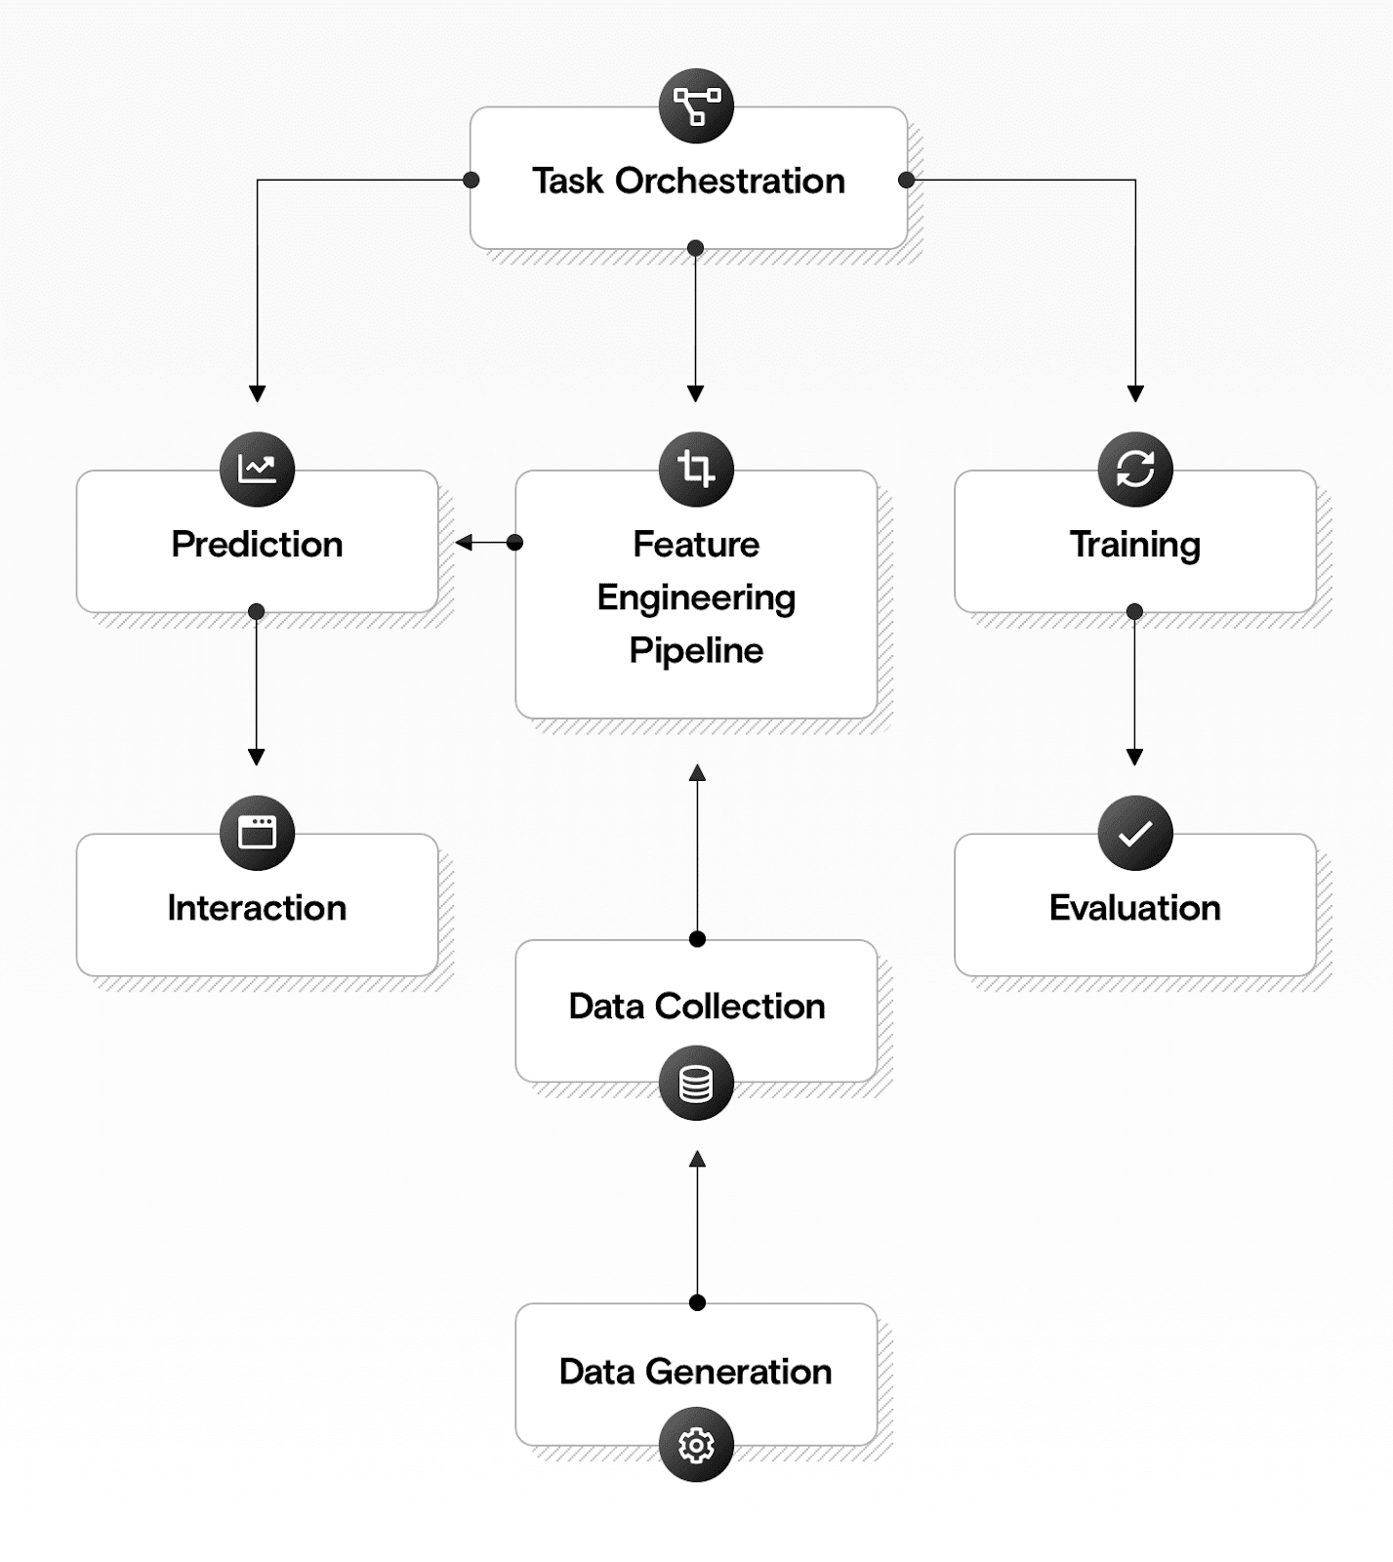

Fig 3.1 Architecture Diagram

**3.7 Data Flow Diagram**

**Level 0**

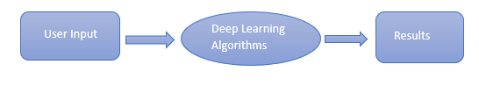

Fig 3.2 DFD level 0

**Level 1**

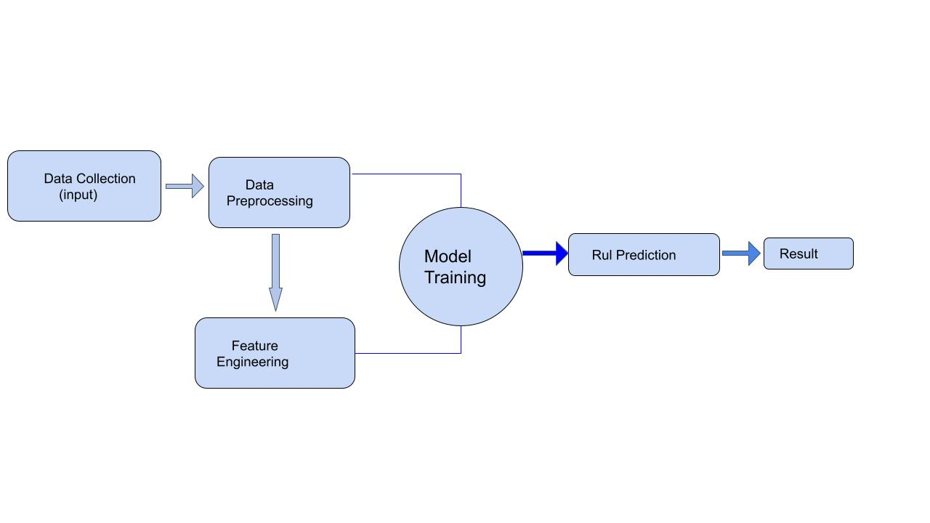

Fig 4.3 DFD level 1

**3.8 Module Diagram**

The steps followed in the proposed approach are

* DATA SET EXTRACTION OF COMMERCIAL AIRCRAFT
* DATA PROCESSING
* FEATURE SELECTION
* TRAINING THE MODEL(LSTM)
* TESTING AND RUL PREDICTION
* PERFORMANCE EVALUATION

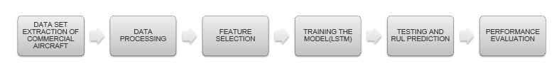

Fig 3.4 Module Diagram

**3.8.1 Dataset Collection**

Engine degradation simulation was carried out using C-MAPSS. Four different sets were simulated under different combinations of operational conditions and fault modes. Records several sensor channels to characterize fault evolution. There data set was provided by the Prognostics CeO at NASA Ames.

**3.8.2 Dataset Description**

The dataset FD001 contains a time series of 21 sensors and 3 settings of 100 units (Commercial Jet engine).Each engine works normally at the beginning of each time series and fails at the end of the time series. Each row is a snapshot of the data taken during a single operation cycle. The training dataset consists of 20631 rows and 26 columns and the testing dataset consists of 13096 rows and 26 columns which is an average of 30% of total values.

|  |  |  |
| --- | --- | --- |
| **Sensor number** | **Sensor Description** | **Units** |
| 1 | Fan inlet temperature | ◦R |
| 2 | LPC outlet temperature | ◦R |
| 3 | HPC outlet temperature | ◦R |
| 4 | LPT outlet temperature | ◦R |
| 5 | Fan inlet pressure | psia |
| 6 | Bypass-duct pressure | psia |
| 7 | HPC outlet pressure | psia |
| 8 | Physical fan speed | rpm |
| 9 | Physical core speed | rpm |
| 10 | Engine pressure ratio P50/P2 | - |
| 11 | HPC outlet static pressure | Psia |
| 12 | Ratio of fuel flow to Ps30 | pps/psia |
| 13 | Corrected fan speed | Rpm |
| 14 | Corrected core speed | Rpm |
| 15 | Bypass ratio | - |
| 16 | Burner fuel–air ratio | - |
| 17 | Bleed enthalpy | - |
| 18 | Required fan speed | Rpm |
| 19 | Required fan conversion speed | Rpm |
| 20 | High-pressure turbines cool air flow | lb/s |
| 21 | Low-pressure turbines cool air flow | lb/s |

**Table 1. Data description of** **Commercial Jet** **engine sensors**

**3.8.3 Data Preprocessing**

Data Exploration

Data visualization

Feature Engineering

**3.8.4 Data Exploration**

* When inspecting the max time cycles we can see
* The engine which failed the earliest did so after 128 cycles,
* Whereas the engine which operated the longest broke down after 362 cycles.
* The average engine breaks between 199 and 206 cycles.
* RUL corresponds to the remaining time cycles for each unit before it fails.

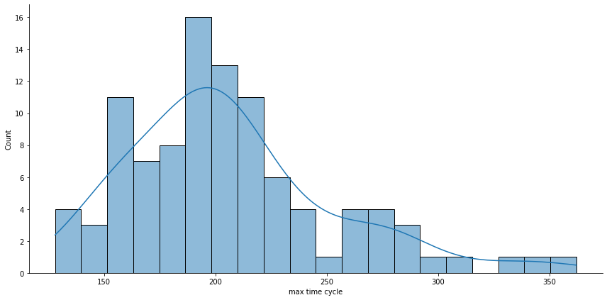

fig 3.5 Time Cycle vs count

From the graph, We notice that most of the time, the maximum time cycles that an engine can achieve is between 190 and 210 before HPC failure.

**3.8.5 Data Visualization**

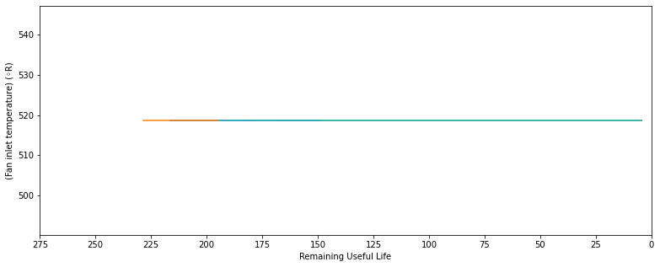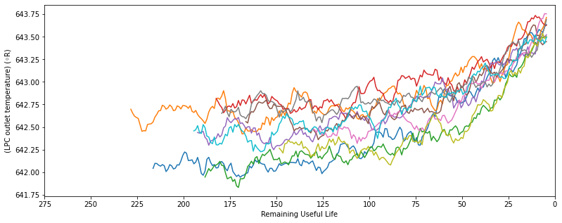

Fig3.6 Rul vs Sensor 1 Fig3.7 Rul vs Sensor 2

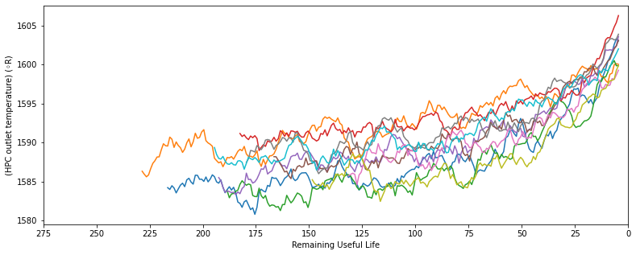 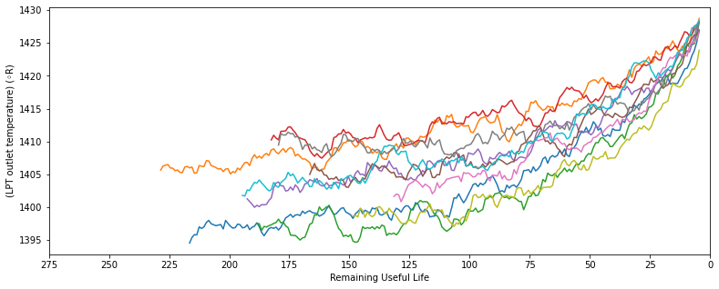

Fig3.8 Rul vs Sensor 3 Fig3.9 Rul vs Sensor 4

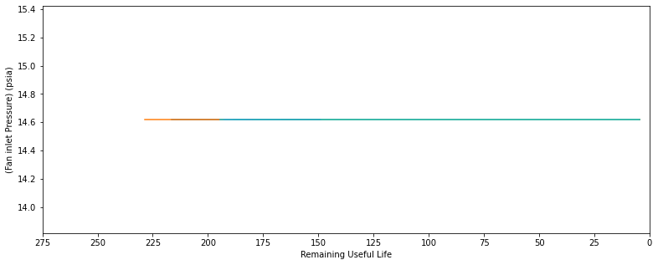 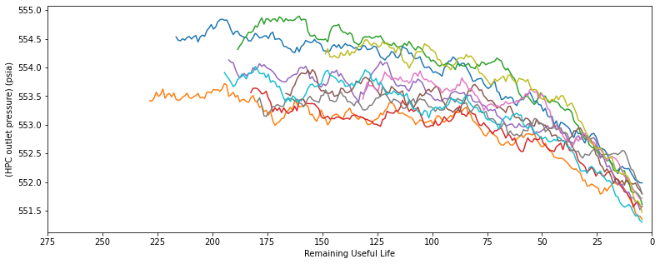

Fig3.10 Rul vs Sensor 5 Fig3.11 Rul vs Sensor 7

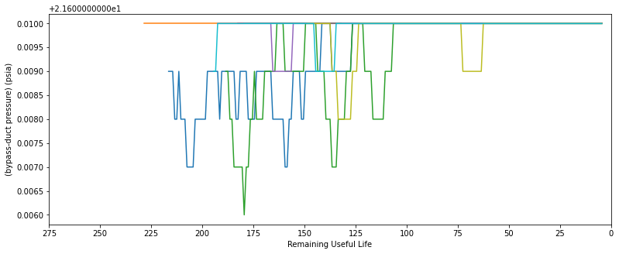

Fig3.12 Rul vs Sensor 6

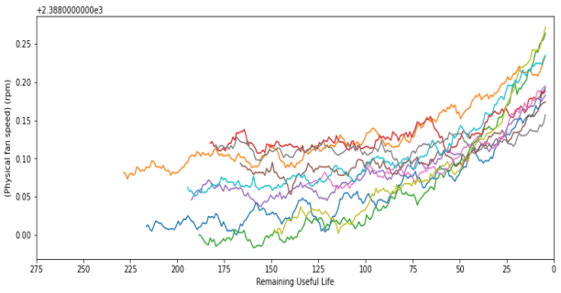 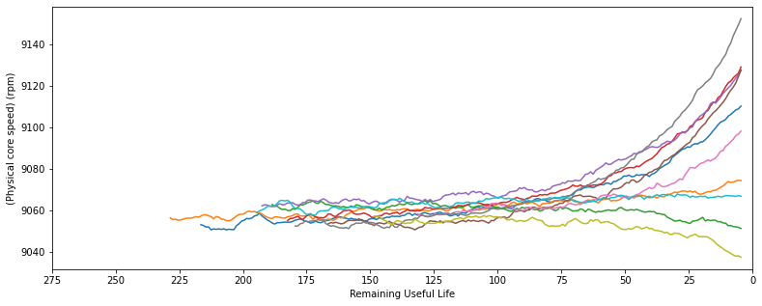

Fig3.13 Rul vs Sensor 8 Fig3.14 Rul vs Sensor 9

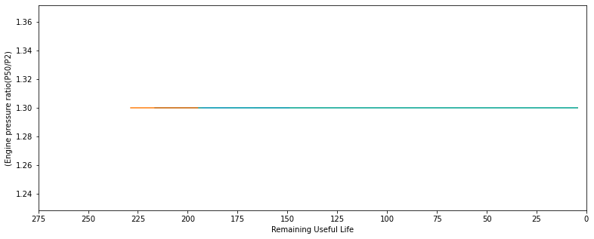 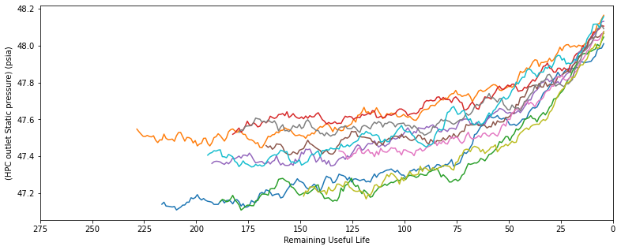

Fig3.15 Rul vs Sensor 10 Fig3.16 Rul vs Sensor 11

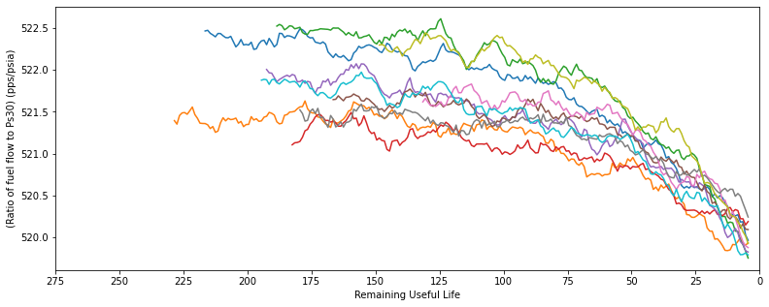 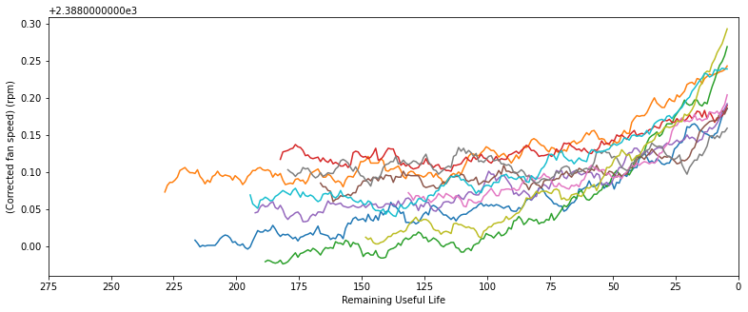

Fig3.16 Rul vs Sensor 12 Fig3.17 Rul vs Sensor 13

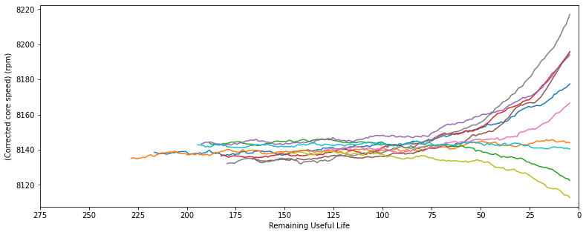 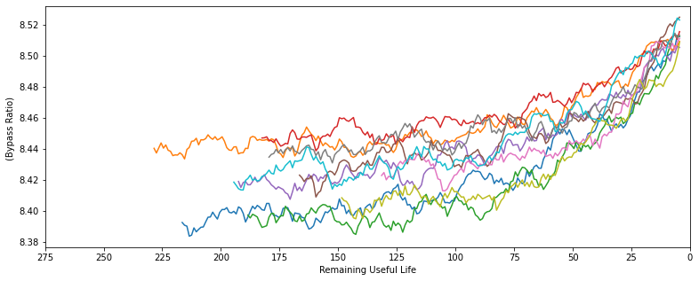

Fig3.18 Rul vs Sensor 14 Fig3.19 Rul vs Sensor 15

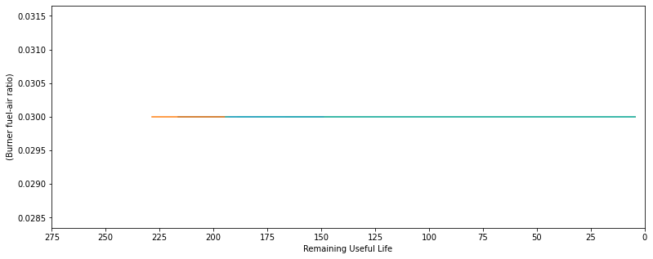 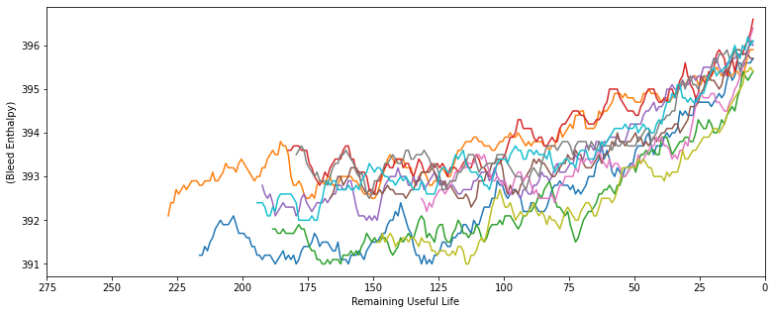

Fig3.20 Rul vs Sensor 16 Fig3.21 Rul vs Sensor17

 

Fig3.22 Rul vs Sensor18 Fig3.23 Rul vs Sensor19

 

Fig3.24 Rul vs Sensor20 Fig3.25 Rul vs Sensor21

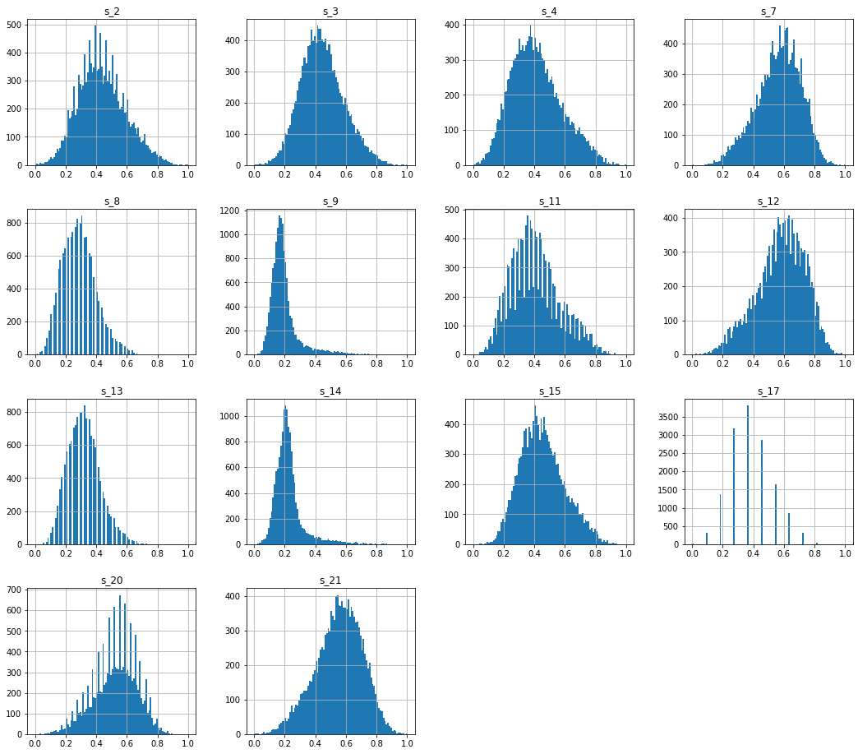

Fig3.26 selected sensors

The plots for the remaining selected features are for sensors 2,3,4,7,8,9,11,12,13,14,15,17,20,21

| **Trend** | **Sensor number** |
| --- | --- |
| Increasing | [2, 3, 4, 8, 11, 13, 14, 15, 17] |
| Decreasing | [7, 12, 20, 21] |
| Irregular | [9, 14] |
| Unchanged | [1, 5, 6, 10, 16, 18, 19] |

**Table 2: Sensor trends summary**

After Visualizing the sensor measurements, we can conclude that

* Sensors 1,10,18,19 are similar hence they hold no information
* The Sensors 5,16 show flat lines, and excluded
* Sensors 2,3,4,8,11,13,15,17 shows rising trends
* The sensor 6 shows the peak downwards
* The sensor 7,12,20,21 shows decreasing trend
* The sensor 9 and 14 shows the similar pattern
* Based on our Exploratory Data Analysis we can determine sensors 1, 5, 6, 10, 16, 18 and 19 hold no information related to RUL as the sensor values remain constant throughout time. so the sensors will be taken for prediction.

**3.9 Feature Engineering**

**3.9.1 Lag Feature**

Lag feature is created by shifting the original time series forward or backward in time by a certain number of time steps. For example, a lag feature of one day for a time series of daily sales data would represent the sales from the previous day. Lag features are commonly used in time series forecasting and prediction tasks, as they can capture the temporal dependencies between past and future values of the time series.

By including lag features in a Deep learning model, it can better capture patterns and trends in the time series data. An engine's Remaining useful life can be estimated based on changes in sensor measurements. For instance, if a certain sensor measurement steadily rises or falls over time, this can be a sign of a degradation tendency that could eventually cause failure.

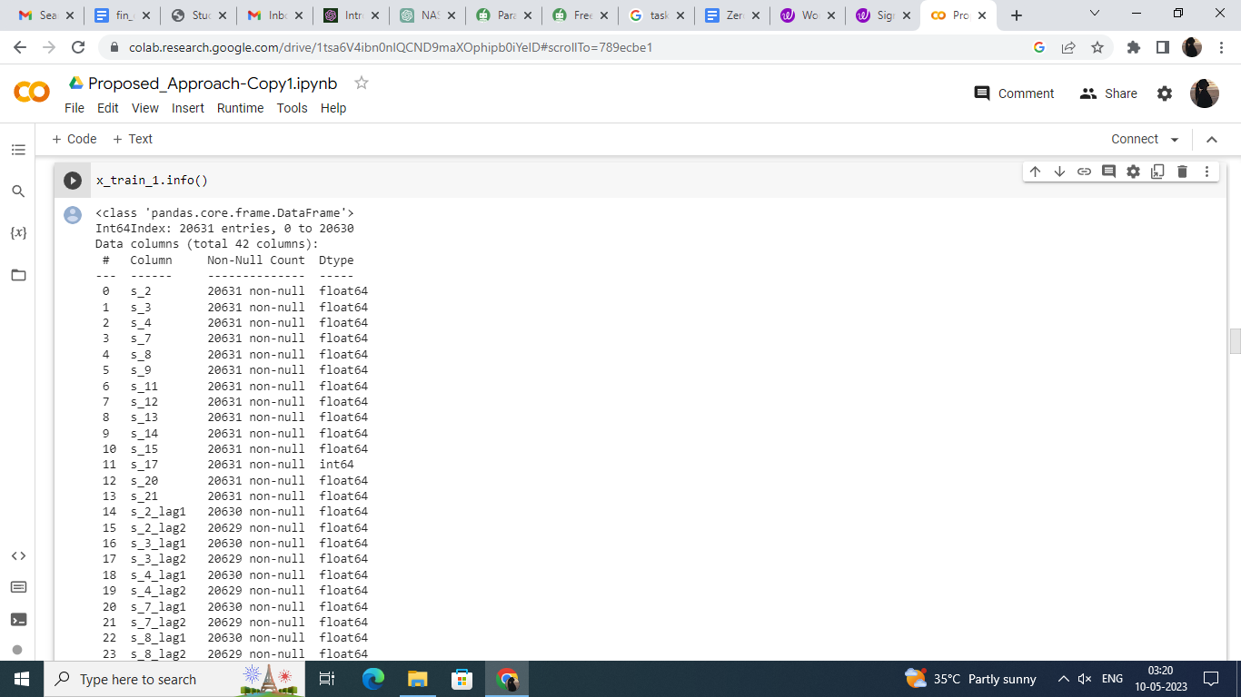

Fig 3.27 lag feature

The column called s_1_lag1 that represents the sensor measurements for s1 shifted by one cycle (i.e., the previous cycle's measurement). We have used the groupby() method to group the data by unit (i.e., engine number) and applied the shift() method to shift the s1 data by one row. Finally, we have removed the rows with missing values using the dropna() method.

**3.9.2 Polynomial Feature**

Polynomial feature transformation can be applied to a wide range of machine learning algorithms, including linear regression, logistic regression, and support vector machines. It can help improve the model's accuracy by capturing complex relationships between the input features and the output variable.

Polynomial feature transformation can also be applied in RUL (Remaining Useful Life) prediction for Commercial Jet engines to capture the non-linear relationships between the sensor measurements and the RUL. In this context, polynomial features represent the higher-order interactions between the sensor measurements, which can be used to predict the RUL more accurately.

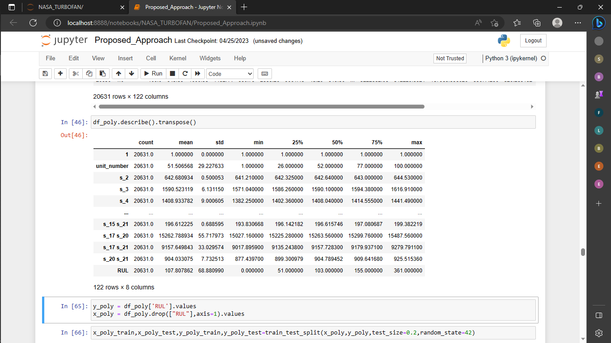

Fig 3.28 polynomial feature

**3.10 Model Building**

**3.10.1 Existing approach**

In the existing system the algorithms like Random Forest Regression, Support Vector Regression, Linear Regression etc are used all algorithms All results give high error rate and less accuracy.

**3.10.1.1 Random Forest Regression**

Random Forest Regression is a supervised learning algorithm that uses ensemble learning methods for regression. Ensemble learning method is a technique that combines predictions from multiple machine learning algorithms to make a more accurate prediction than a single model.

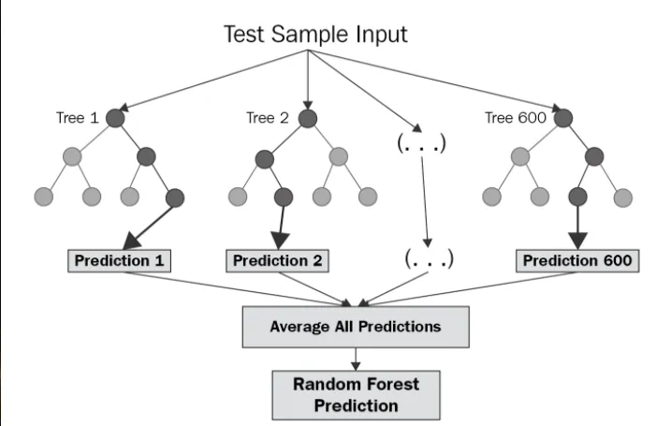

Fig 3.29 Architecture of random forest

1. This Random Forest is a simple supervised algorithm.

2. Each node in the tree represents a decision based on the values of one of the sensor inputs. The decision tree uses these sensor values to predict the RUL of the turbofan engine at each time point.

**3.10.1.2 Support Vector Regressor**

Support Vector Regression (SVR) is a type of machine learning algorithm used for regression analysis. The goal of SVR is to find a function that approximates the relationship between the input variables and a continuous target variable, while minimizing the prediction error.

SVR can handle non-linear relationships between the input variables and the target variable by using a kernel function to map the data to a higher-dimensional space. This makes it a powerful tool for regression tasks where there may be complex relationships between the input variables and the target variable.

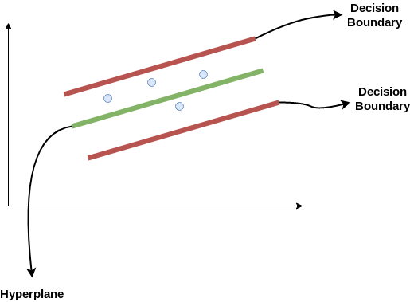

Fig 3.30 Architecture of support vector regression

1. Support Vector Regression is a supervised learning algorithm that is used to predict discrete values

2. Support Vector Regression uses the same principle as the SVMs. The basic idea behind SVR is to find the best-fit line. In SVR, the best-fit line is the hyperplane that has the maximum number of points.

**3.10.1.3 Linear Regression**

Linear regression is a type of statistical analysis used to predict the relationship between two variables. It assumes a linear relationship between the independent variable and the dependent variable, and aims to find the best-fitting line that describes the relationship. The line is determined by minimizing the sum of the squared differences between the predicted values and the actual values.

Linear regression is a quiet and the simplest statistical regression method used for predictive analysis in machine learning. Linear regression shows the linear relationship between the independent(predictor) variable i.e. X-axis and the dependent(output) variable i.e. Y-axis, called linear regression. If there is a single input variable X(independent variable), such linear regression is called simple linear regression.

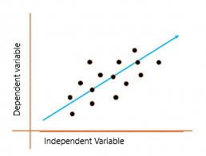

Fig 3.31 Architecture of Linear regression

1. Linear regression analysis is used to predict the value of a variable based on the value of another variable. The variable you want to predict is called the dependent variable.

2. The variable you are using to predict the other variable's value is called the independent variable

**3.10.1.4 Performance metrics**

**3.10.1.4.1 All Features Without Historical Data**

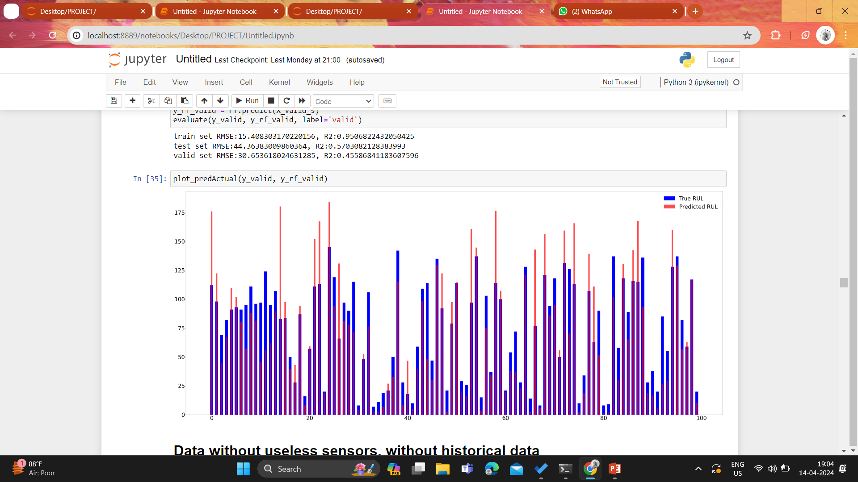

Fig 3.32 All Features Without Historical Data

**Linear Regression:**

train set RMSE:56.19869318681088, R2:0.3439361345919162

test set RMSE:54.264009074691856, R2:0.35713062175493715

valid set RMSE:34.84962228223509, R2:0.2967064952591344

**Support Vector Regressor:**

train set RMSE:43.56448464126648, R2:0.605761670162996

test set RMSE:47.26718449996112, R2:0.5122262167433573

valid set RMSE:34.84962228223509, R2:0.2967064952591344

**Random forest Regression:**

train set RMSE:15.408303170220156, R2:0.9506822432050425

test set RMSE:44.36383009860364, R2:0.5703082128383993

valid set RMSE:30.653618024631285, R2:0.45586841183607596

**3.10.1.4.2 Data Without Useless Sensors, Without Historical Data**

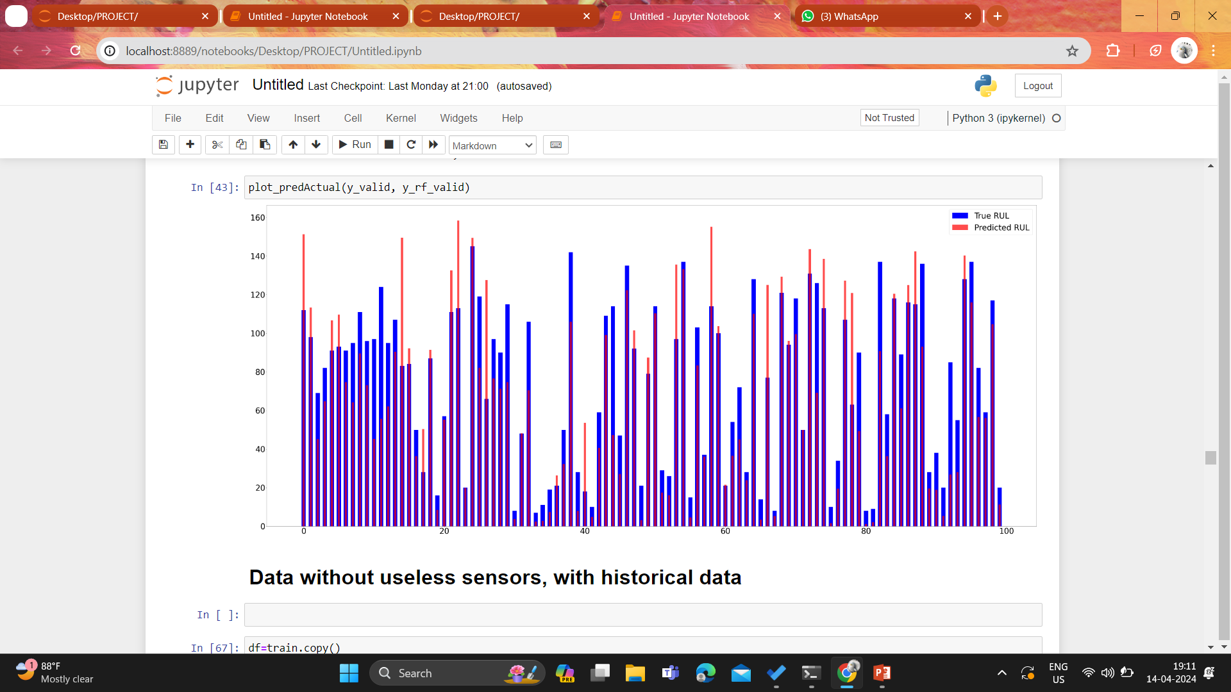

Fig 3.33 Data Without Useless Sensors, Without Historical Data

**Linear Regression:**

train set RMSE:47.86312955545103, R2:0.3792662465007206

test set RMSE:55.6261002397046, R2:0.3244519972933424

valid set RMSE:34.21070108960351, R2:0.3222579927041398

**Support Vector Regressor:**

train set RMSE:32.91543148706822, R2:0.7064363470171213

test set RMSE:48.75516379159361, R2:0.48103242301470384

valid set RMSE:25.947912225366203, R2:0.6101071274546097

**Random forest Regression:**

train set RMSE:12.036862499525814, R2:0.9607418547981479

test set RMSE:45.81838291793876, R2:0.5416697719315231

valid set RMSE:26.548403567823055, R2:0.5918523714819

**3.10.1.4.3 Data Without Useless Sensors, With Historical Data**

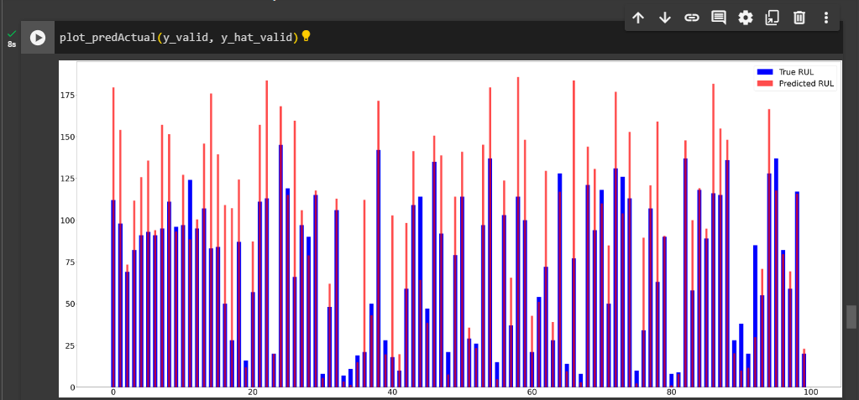

Fig 3.34 Data Without Useless Sensors, With Historical Data

**Linear Regression:**

train set RMSE:36.12278318538548, R2:0.6461026809508146

test set RMSE:36.24759043148782, R2:0.6359939567063242

valid set RMSE:33.12521026826295, R2:0.3645845897590453

**Support Vector Regressor:**

train set RMSE:32.313524381002445, R2:0.7168063437968639

test set RMSE:32.7061504393512, R2:0.7036471078045101

valid set RMSE:34.076921735663475, R2:0.3275481860480176

**Random forest Regression:**

train set RMSE:9.785392549750972, R2:0.974030034737145

test set RMSE:26.696381891435006, R2:0.802550916397019

valid set RMSE:34.099712755388424, R2:0.3266483989294847

**3.10.2 Proposed Approach**

**Long Short-Term Memory (LSTM)**

LSTM is a special type of RNN algorithm that evolved to overcome the demerits of the RNN algorithm i.e., short-term memory of sequence. RNN isn't able to predict the solution for big scenarios and context. LSTM can remember the essential context for the long term and can forget unnecessary things using forget gates and add a gate, used more familiarly than RNN due to its memory capability. Forget gate is designed using the sigmoid function which is used to remove the unwanted memory in the LSTM cell. Add gate is designed by using tanh and sigmoid function. In NLP, a sequence of words or sentences passed over a period of time, the output of each cell may take or regret and pass to the next cell depending upon the problems and scenarios.

1. LSTM stands for long short-term memory networks, used in the field of Deep Learning. It is a variety of recurrent neural networks (RNNs) that are capable of learning long-term dependencies, especially in sequence prediction problems.

2. LSTM in RUL prediction, we can capture the temporal dependencies between the sensor measurements and RUL, and also handle the non-linearity and complex relationships between the features. LSTM can provide accurate and reliable RUL predictions, which can help in proactive maintenance scheduling and reduce the risk of equipment failure.

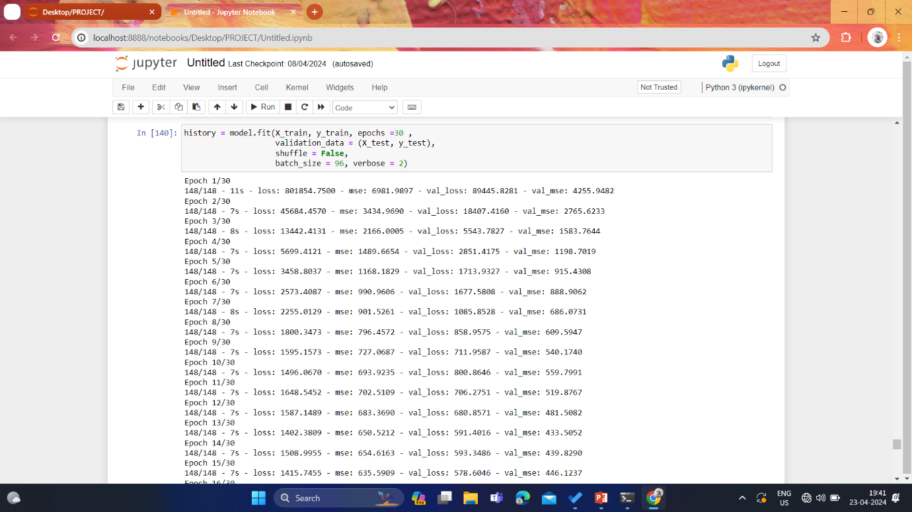

Fig 3.35 LSTM Model

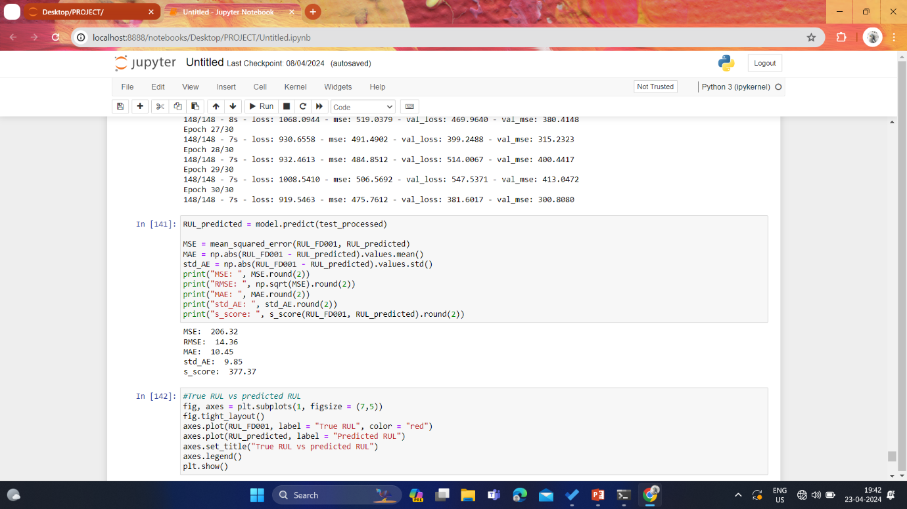

Fig 3.36 LSTM Model

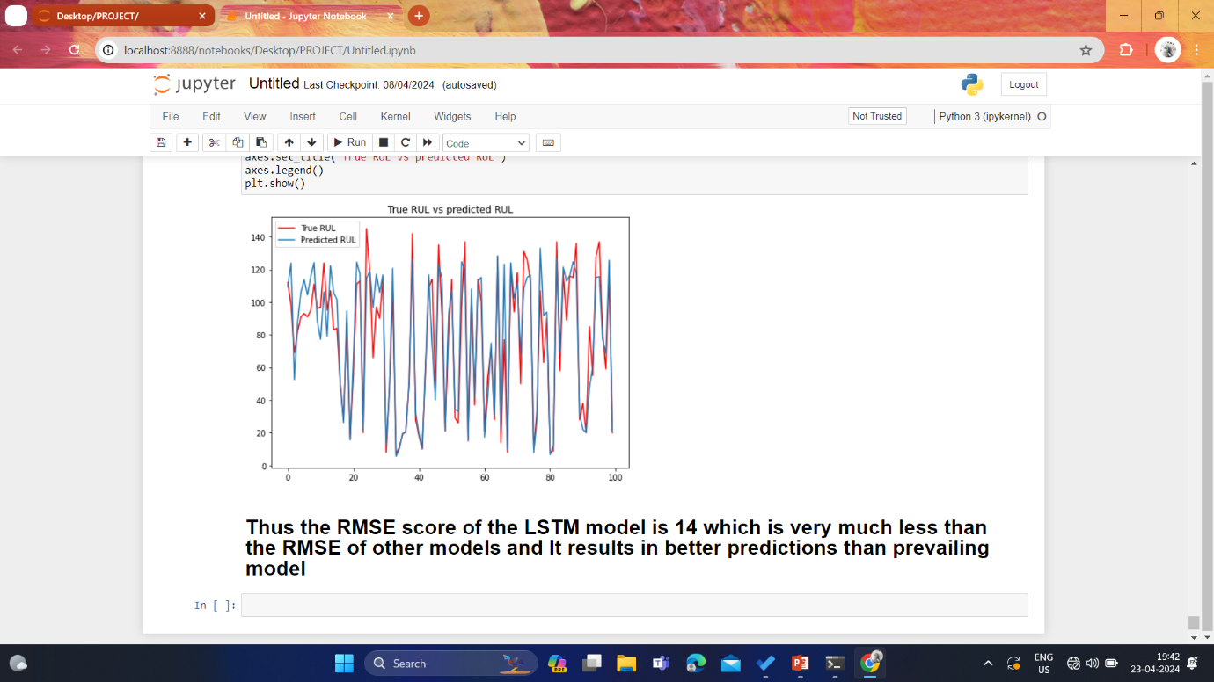

Fig 3.39 LSTM Model Graph

MSE: 206.32

RMSE: 14.36

MAE: 10.45

std_AE: 9.85

s_score: 377.37

**CHAPTER - 4**

**RESULTS AND DISCUSSION**

The goal of the project was to enhance the accuracy of the deep learning model by utilizing feature selection techniques. These techniques aimed to decrease the training time of the model while still retaining a significant number of effective features. Our proposed approach utilized the LSTM deep learning algorithm, which led to a notable increase in accuracy.

We utilized the LSTM deep learning algorithm, which is a type of recurrent neural network that is specifically designed to handle sequential data. LSTM is capable of learning long-term dependencies in data, making it ideal for predicting time-series data. By using LSTM, we were able to build a highly accurate model that could effectively predict outcomes based on a sequence of input data.

The application of LSTM contributed to the reduced the RMSE of the model, indicating the effectiveness of using deep learning algorithms in predictive modeling. Overall, our proposed approach offers a promising solution for enhancing the RUL prediction of deep learning models while reducing the duration of training.

**Result:**

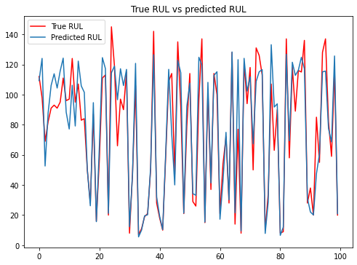

MSE: 206.32

RMSE: 14.36

MAE: 10.45

std_AE: 9.85

s_score: 377.37

**CHAPTER - 5**

**CONCLUSION AND FUTURE WORKS**

In conclusion, the project aimed to revolutionize engine health management in the aviation industry by leveraging deep learning techniques, particularly the Long Short-Term Memory (LSTM) algorithm, to predict the Remaining Useful Life (RUL) of Commercial Jet engines

Predicting the RUL of critical components like jet engines is crucial for cost savings, safety, efficiency, and reliability in the aircraft industry. By accurately estimating the time until failure, operators can schedule maintenance activities more effectively, optimize engine performance, and prevent catastrophic failures.

Traditional methods such as regression models, prognostic models, survival analysis, and expert systems have limitations in capturing complex relationships and providing reliable predictions. Deep learning techniques offer a promising solution to overcome these challenges by handling non-linearity, temporal dependencies, and complex data patterns.

LSTM, a type of recurrent neural network, excels in learning long-term dependencies in sequential data, making it well-suited for time-series prediction tasks like RUL estimation. Its ability to capture temporal dependencies and handle complex relationships between features contributes to more accurate and reliable predictions compared to traditional approaches.

The project proposed a methodology that involved data collection, preprocessing, feature engineering, and LSTM model building. By utilizing LSTM and feature selection techniques, the accuracy of the RUL prediction model was significantly enhanced, as evidenced by the reduced Root Mean Square Error (RMSE) and improved prediction performance.

The successful application of LSTM in RUL prediction opens up opportunities for proactive maintenance scheduling, cost reduction, and enhanced safety in the aviation industry. Future research could focus on further optimizing deep learning models, exploring additional features, and integrating real-time data for more dynamic predictions.

**REFERENCES**

[1] Que, Z., Jin, X. & Xu, Z. RUL prediction for bearings based on a gated recurrent unit. *IEEE Trans. Instrum. Meas.* **15**(10), 10–28 (2021).

[2] Zhao, S. *et al.* Health state estimation and RUL prediction of power devices subject to noisy and aperiodic condition monitoring. *IEEE Trans. Instrum. Meas.* **14**(6), 102–125 (2021).

   
[3] Cao, Y. *et al.* Transfer learning for RUL prediction of multi-conditions bearings based on bidirectional-GRU network. *Measurement* **178**(5), 109–127 (2021).

[4] Li X, Ding Q, Sun J-Q. RUL estimation in prognostics using deep convolution neural networks. ReliabEng Syst Saf2018;172:1–11.

 [5] Peng Y, Wang Y, Zi Y. Switching state-space degradation model with recursive filter/smoother for prognostics of RUL. IEEE Trans Ind Inf 2018.

[6] Zheng S, Ristovski K, Farahat A, Gupta C. Long short-term memory network for RUL estimation. 2017 IEEE International Conference on Prognostics and Health Management (ICPHM). IEEE; 2017. p. 88–95  
  
  
 [7] Zhao G, Zhang G, Ge Q, Liu X. Research advances in fault diagnosis and prognostic based on deep learning. Prognostics and System Health Management Conference (PHM-Chengdu). IEEE; 2016. p. 1–6.

 [8] Sateesh Babu G, Zhao P, Li X-L. Deep convolutional neural network based regression approach for estimation of RUL. Cham: Springer International Publishing; 2016. p. 214–28. https://doi.org/10.1007/978-3-319

[9] He K, Zhang X, Ren S, Sun J. Delving deep into rectifiers: Surpassing human-level performance on imagenet classification. Proceedings of the IEEE international conference on computer vision. 2015. p. 1026–34  
  
  
[10] Chen XW, Lin X. Big data deep learning: challenges and perspectives. IEEE Access 2014;2:514–25. https://doi.org/10.1109/ACCESS.2014.2325029.

[11] Srivastava N, Hinton G, Krizhevsky A, Sutskever I, Salakhutdinov R. Dropout: a simple way to prevent neural networks from overfitting. J Mach Learn Res2014;15(1):1929–58

[12] Glorot X, Bordes A, Bengio Y. Deep sparse rectifier neural networks. In: Gordon G, Dunson D, DudÃk M, editors. Proceedings of the Fourteenth International Conference on Artificial Intelligence and Statistics; vol. 15 of Proceedings of Machine Learning Research. Fort Lauderdale, FL, USA: PMLR; 2011.315–23.   
  
  
[13] Glorot X, Bengio Y. Understanding the difficulty of training deep feedforward neural networks. Proceedings of the 13th International Conference on Artificial Intelligence and Statistics. 2010. p. 249–56.

[14] Erhan D, Manzagol P-A, Bengio Y, Bengio S, Vincent P. The difficulty of training deep architectures and the effect of unsupervised pre-training. Artificial Intelligence and Statistics. 2009. p.53–60.

[15] Kalgren PW, Byington CS, Roemer MJ, Watson MJ. Defining phm, a lexical evolution of maintenance and logistics. 2006 IEEE Autotestcon. 2006. p. 353–8. https:// doi.org/10.1109/AUTEST.2006.283685.

[16] Felix Heimes.Prognostics and Health Management, 2008. PHM 2008 ,Prognostics and Health Management, 2008, PHM 2008.

[17] Bengio, Y., Courville, A., Vincent, P.: Representation learning: a review and new perspectives. IEEE Trans. Pattern Anal. Mach. Intell. 35(8), 1798–1828 (2013)

[18] Bengio, Y.: Learning deep architectures for AI. Found. Trends Mach. Learn. 2(1), 1–127 (2009)

[19 ]Collobert, R., Weston, J.: A unified architecture for natural language processing: deep neural networks with multitask learning. In: Proceedings of the 25th International Conference on Machine Learning, pp. 160–167. ACM (2008)

[20] Park D, Hoshi Y, Kemp CC. A multimodal anomaly detector for robot-assistedfeeding using an lstm-based variational autoencoder. IEEE Rob Autom Lett2018;3(3):1544–51.A. Listou Ellefsen et al. Reliability Engineering and System Safety 183 (2019) 240–251251

[21] Gers FA, Schmidhuber JA, Cummins FA. Learning to forget: continual predictionwith lstm. Neural Comput 2000;12(10):2451–71.

[22] Greﬀ K, Srivastava RK, Koutník J, Steunebrink BR, Schmidhuber J. Lstm: a searchspace odyssey. IEEE Trans Neural Netw Learn Syst 2017;28(10):2222–32.

[23] Eclipse deeplearning4j development team, deeplearning4j: open-source distributeddeep learning for the jvm. Apache Software Foundation License 20 http://deeplearning4jorg 2018;

[24] Hinton GE, Osindero S, Teh Y-W. A fast learning algorithm for deep belief nets. sNeural Comput 2006;18(7):1527–54. https://doi.org/10.1162/neco.2006.18.7.1527.

[25] Taigman Y, Yang M, Ranzato M, Wolf L. Deepface: closing the gap to human-levelperformance in face veriﬁcation. 2014 IEEE Conference on Computer Vision and Pattern Recognition. 2014. p. 1701–8.